Weekly Coding Exercise #1

**Task:** Create a question that tests students’ knowledge of a lesson.

**File:** CPG_CW2_WeeklyExercise1.txt

https://www.surveymonkey.com/s/LJQL3PC

**Task Log:**

|  |  |  |  |  |  |
| --- | --- | --- | --- | --- | --- |
| **Task** | **Date** | **Start** | **End** | **Interruptions** | **Minutes** |
| Find a survey-hosting website to us | 04/05/2014 | 19:55 | 20:00 |  | 5 |
| Write questions | 04/05/2014 | 20:00 | 20:10 |  | 10 |
| Finish off survey | 04/05/2014 | 20:10 | 20:15 |  | 5 |

Weekly Coding Exercise #2

**Task:** Write a piece of code that uses interpolation (or lerping) to move an object from point A to B.

**File:** CPG_CW2_WeeklyExercise2.cs

**Task Log:**

|  |  |  |  |  |  |
| --- | --- | --- | --- | --- | --- |
| **Task** | **Date** | **Start** | **End** | **Interruptions** | **Minutes** |
| Research lerping on Unity Scripting Reference | 04/05/2014 | 20:30 | 20:40 |  | 10 |
| Create MonoDevelop Unity C# file | 04/05/2014 | 20:40 | 20:45 |  | 5 |
| Write and test code | 04/05/2014 | 20:45 | 21:00 |  | 15 |

Weekly Coding Exercise #3

**Task:** Use the lerping code created previously on multiple Unity GameObjects and trail renderers to draw an image.

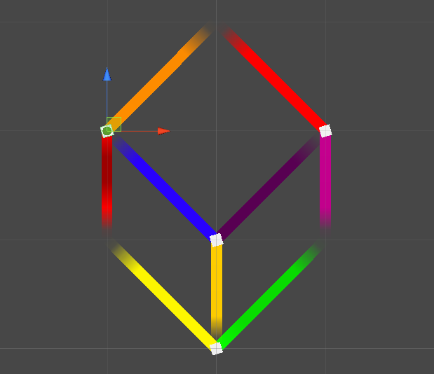**File:** CPG_CW2_WeeklyExercise3.exe

**Task Log:**

|  |  |  |  |  |  |
| --- | --- | --- | --- | --- | --- |
| **Task** | **Date** | **Start** | **End** | **Interruptions** | **Minutes** |
| Create Unity Project | 05/05/2014 | 16:30 | 16:35 |  | 5 |
| Add gameobjects and effects | 05/05/2014 | 16:35 | 16:45 |  | 10 |
| Implement code | 05/05/2014 | 16:45 | 16:50 |  | 5 |

Weekly Coding Exercise #4

**Task:** Use a mathematical problem and convert it into a program.

**File:** CPG_CW2_WeeklyExercise4.cs

C:\Users\Student\Downloads\00bfa02054245d43ac0fc018ece05fc6.png

**Task Log:**

|  |  |  |  |  |  |
| --- | --- | --- | --- | --- | --- |
| **Task** | **Date** | **Start** | **End** | **Interruptions** | **Minutes** |
| Research velocity forumla | 05/05/2014 | 16:50 | 17:10 |  | 20 |
| Code “ObjectHover” script using formula | 05/05/2014 | 17:10 | 17:25 |  | 15 |
| Debug and submit | 05/05/2014 | 17:25 | 17:30 |  | 5 |

Weekly Coding Exercise #5

**Task:** Summarize a games design into a tech tree.

**File:**

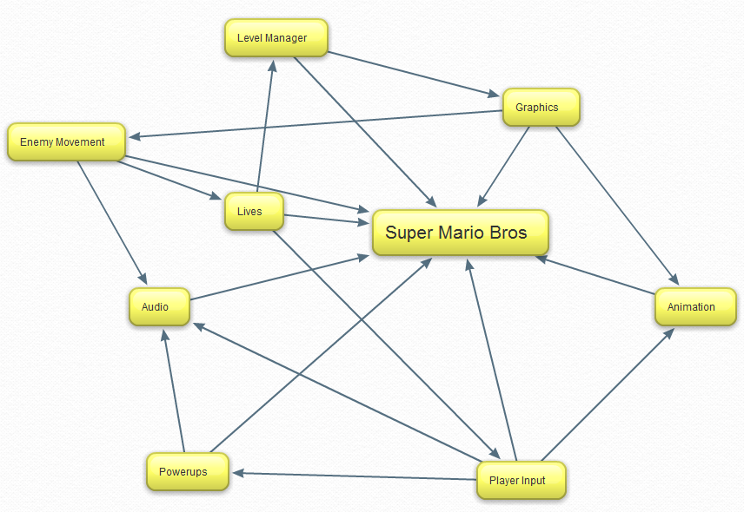

**Task Log:**

|  |  |  |  |  |  |
| --- | --- | --- | --- | --- | --- |
| **Task** | **Date** | **Start** | **End** | **Interruptions** | **Minutes** |
| Research game to deconstruct | 08/05/2014 | 14:15 | 14:20 |  | 5 |
| Study games mechanics | 08/05/2014 | 14:20 | 14:30 |  | 10 |
| Create tech tree | 08/05/2014 | 14:30 | 14:35 |  | 5 |

Weekly Coding Exercise #6

**Task:** Take an everyday object and describe it if I was a Martian.

**File:** CPG_CW2_WeeklyExercise6.txt

**Task Log:**

|  |  |  |  |  |  |
| --- | --- | --- | --- | --- | --- |
| **Task** | **Date** | **Start** | **End** | **Interruptions** | **Minutes** |
| Decide what to study | 08/05/2014 | 15:00 | 15:10 |  | 10 |
| Research topic | 08/05/2014 | 15:10 | 15:20 |  | 10 |
| Write-up descriptnio | 08/05/2014 | 15:20 | 15:30 |  | 10 |